**ASSIGNMENT-2**

**1.write a program for strCmp()**

**Pseudocode:**

Begin

Take input two strings

Run loop from starting index 0 to end character ‘\0’

Compare every character from starting index if(a[i]!=b[i])

Print not equal and exit from loop

Else print equal

end

**C program:**

#include<stdio.h>

void main()

{

char a[100],b[100],i;

printf("enter a string:");

gets(a);

puts(a);

printf("enter b string:");

gets(b);

puts(b);

for(i=0;a[i]!='\0';i++)

{

if(a[i]!=b[i])

{

printf("not equal");

exit(0);

}

else

{

printf("equal");

break;

}

}

}

**Output:**

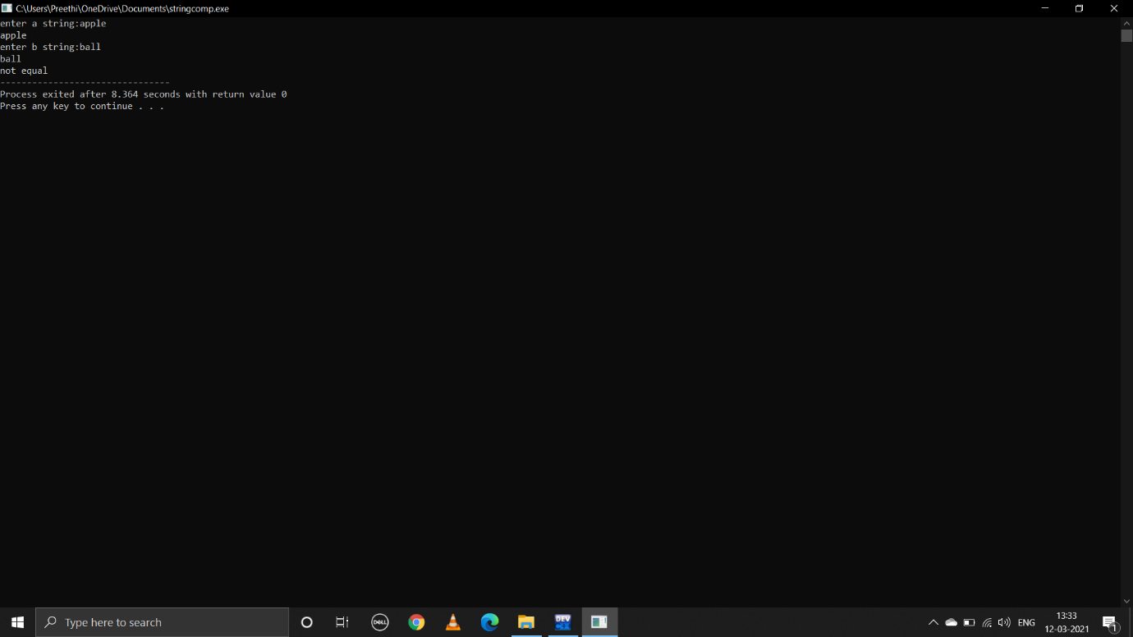

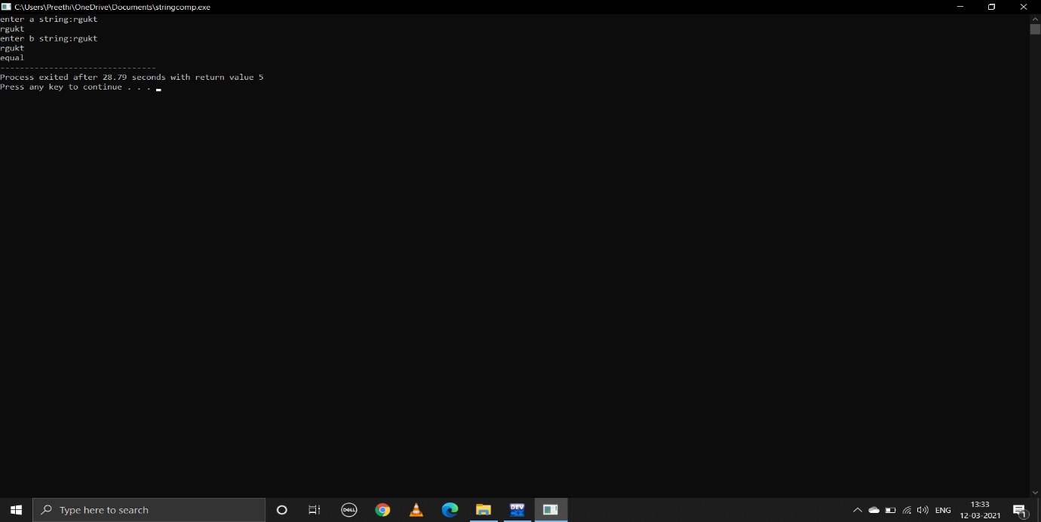

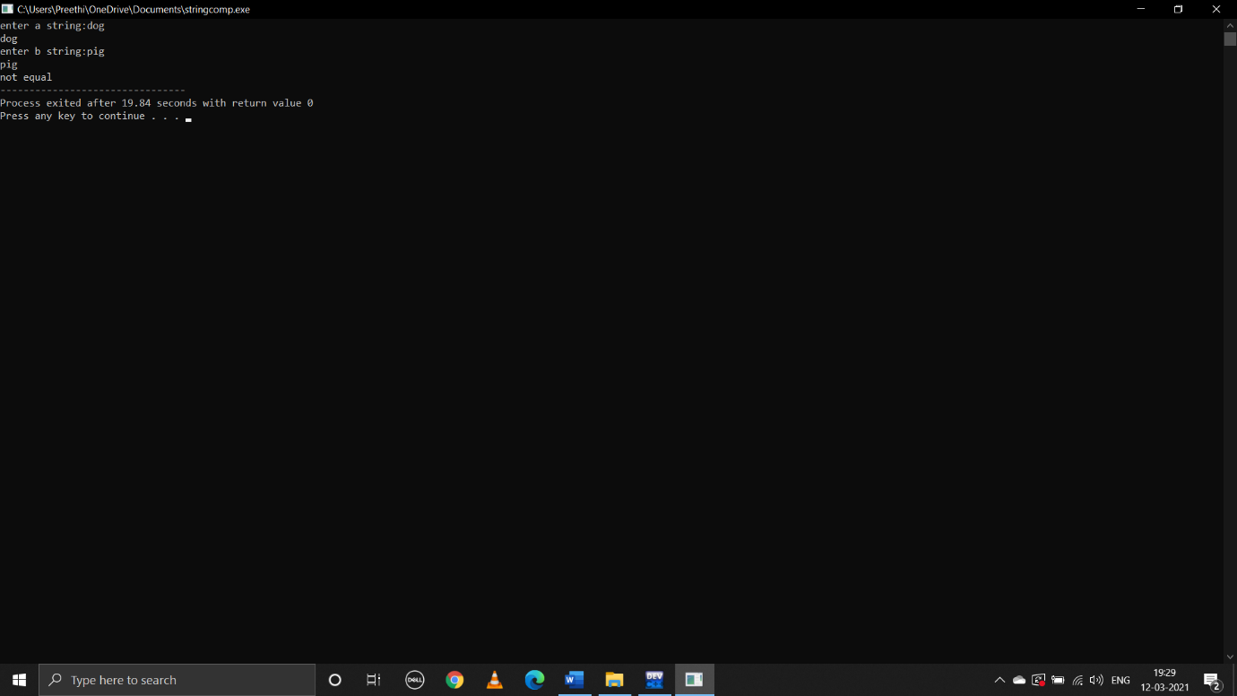

**2.write c program for strCpy()**

**Pseudocode:**

Begin

Take input string

Declare another string

Run loop from i=0 to end character ‘\0’

Copy every character of input string to declared string

Cpy[i]=str[i]

Print cpy

end

**C program:**

#include<stdio.h>

#include<string.h>

void main()

{

char str[1000];

char cpy[1000];

printf("enter string:");

gets(str);

puts(str);

int i;

for(i=0;str[i]!='\0';i++)

{

cpy[i]=str[i];

}

printf("copy of string is %s",cpy);

}

**Output:**

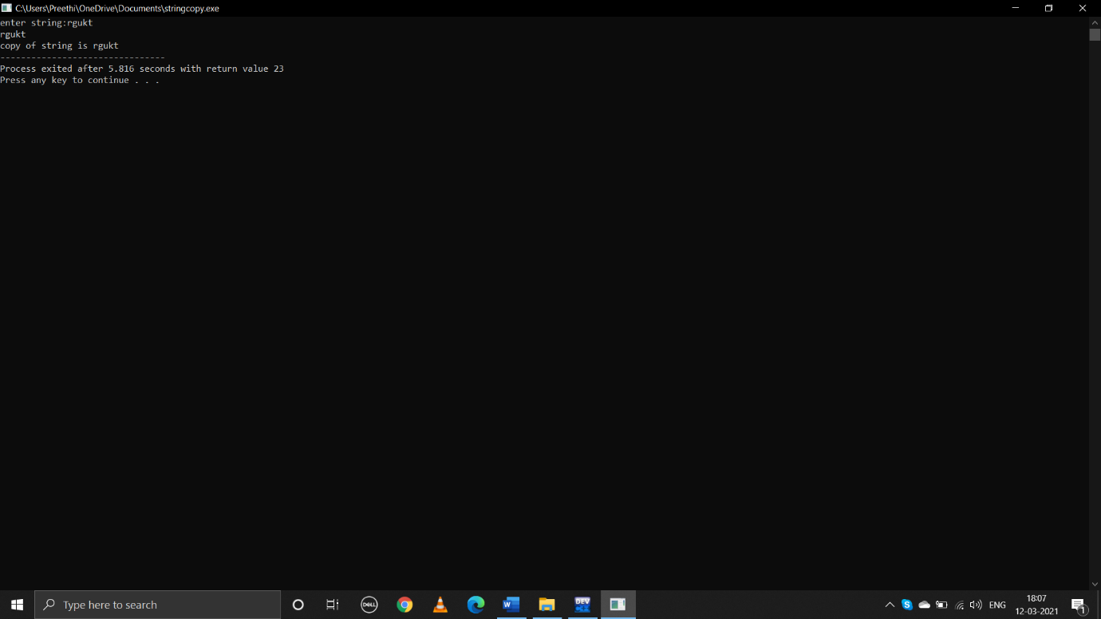

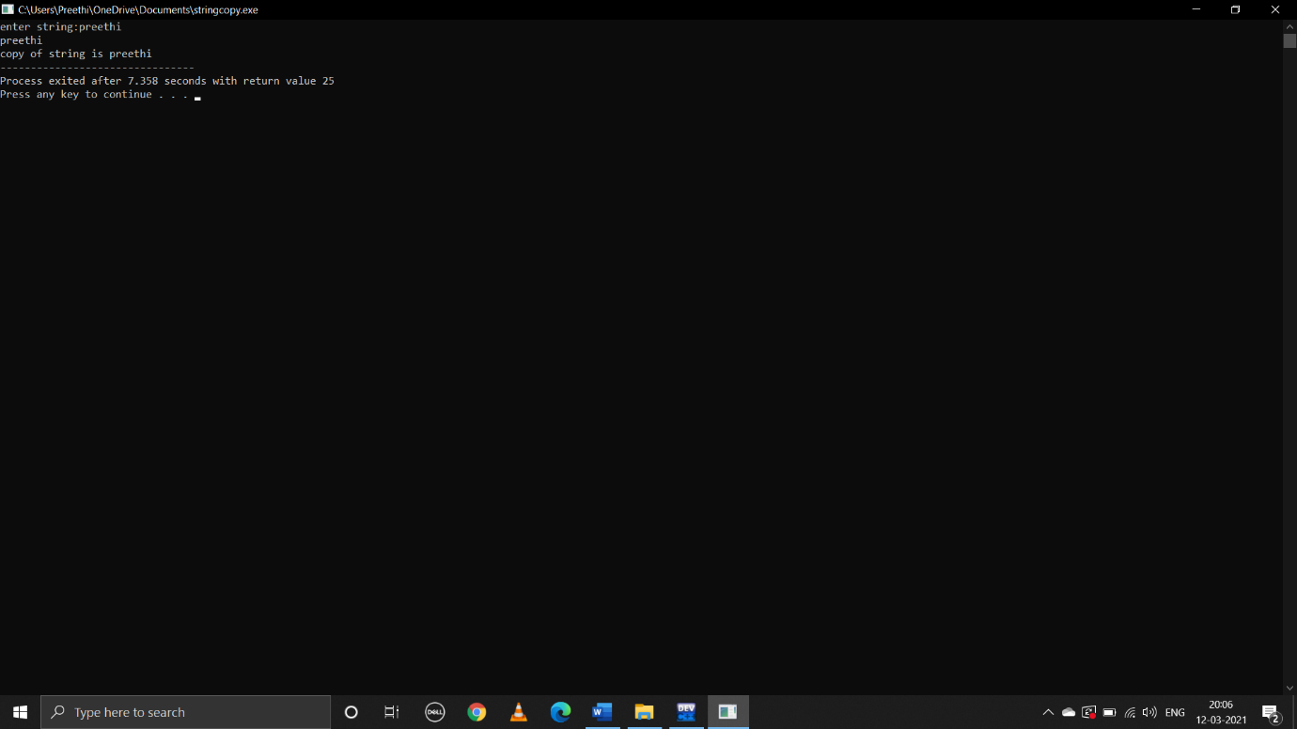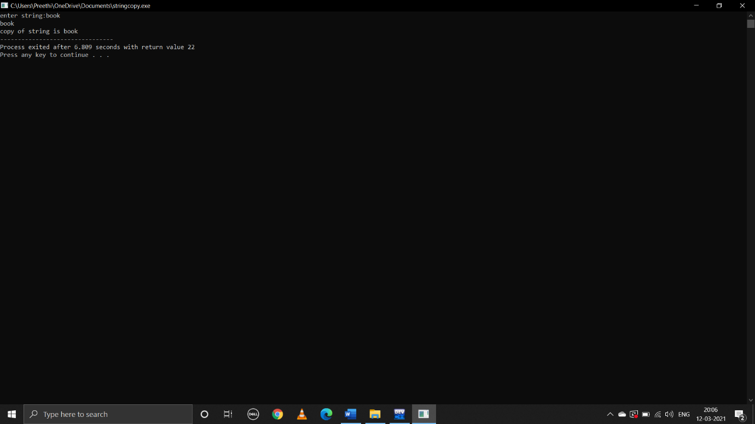

**3.write a c program to strCat()**

**Pseudocode:**

Begin

Take input two strings str1 str2

Int i=0,j=0;

While(str[i]!=’\0’)

i++;

while(str[j]!=’\0’)

add every character of second string to the end of 1st string

str1[i]=str2[j]

j++

i++

print conceated string str1

**C program:**

#include<stdio.h>

#include<string.h>

void main()

{

char str1[1000];

char str2[1000];

printf("enter str1:");

gets(str1);

puts(str1);

printf("enter str2:");

gets(str2);

puts(str2);

int i=0,j=0;

while(str1[i]!='\0')

{

i++;

}

while(str2[j]!='\0')

{

str1[i]=str2[j];

j++;

i++;

}

printf("conceated string is %s",str1);

}

**Output:**

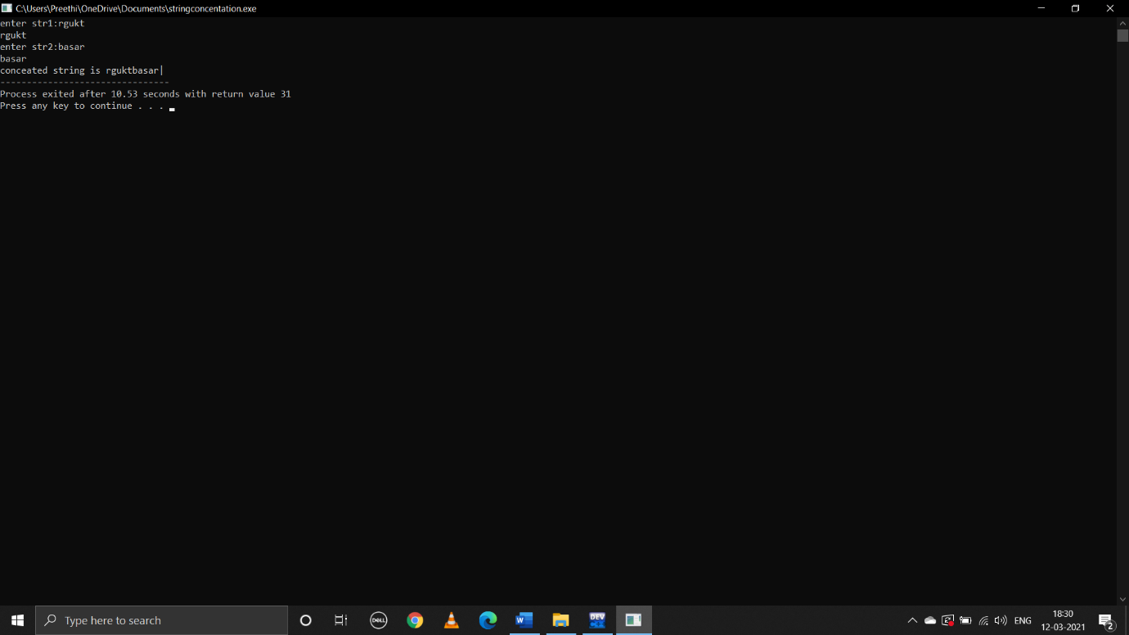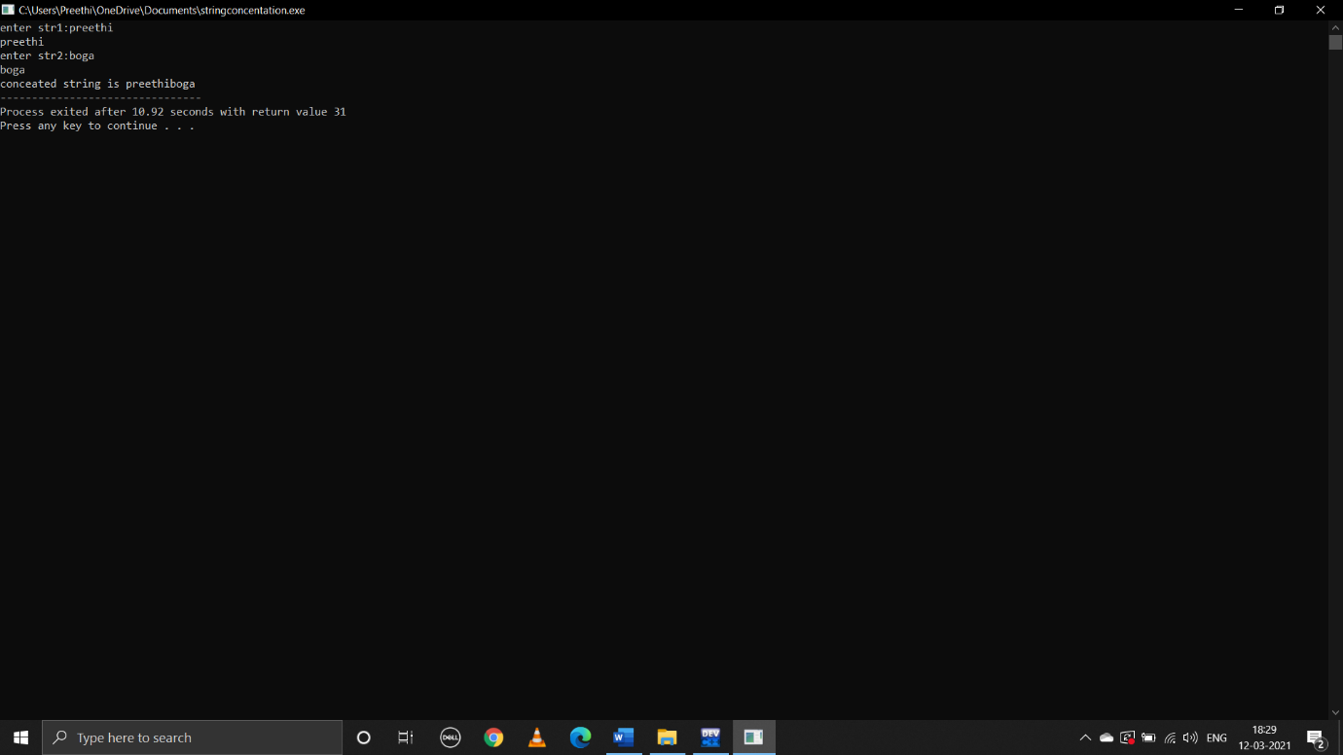

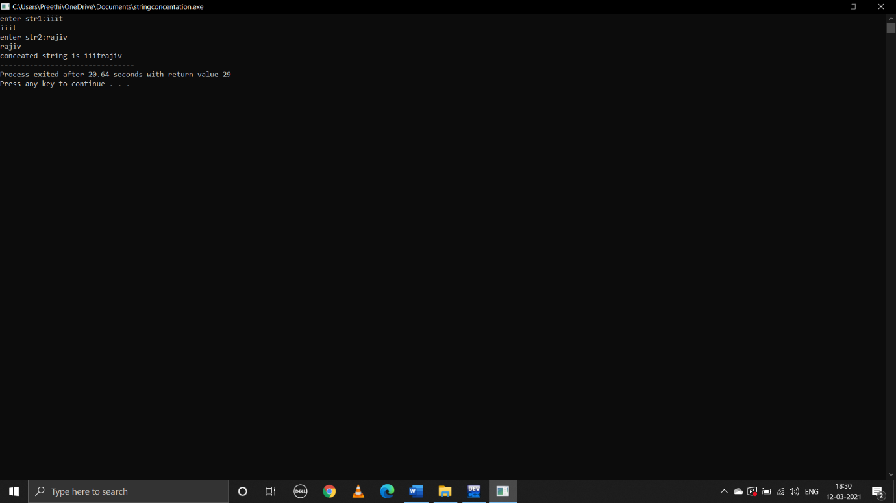

**4.write a c program to stRev()**

**Pseudocode:**

Begin

Take input string str

Declare another string rev[]

Runloop from strlen(str)-1 to 0 index

Copy every character to rev[]

rev[i]=str[i]

print rev

end

**C program:**

#include<stdio.h>

#include<string.h>

void main()

{

char str[1000],rev[1000];

printf("enter string:");

gets(str);

puts(str);

int i;

printf("reverse of string is:");

for(i=strlen(str)-1;i>=0;i--)

{

rev[i]=str[i];

printf("%c",rev[i]);

}

}

**Output**:

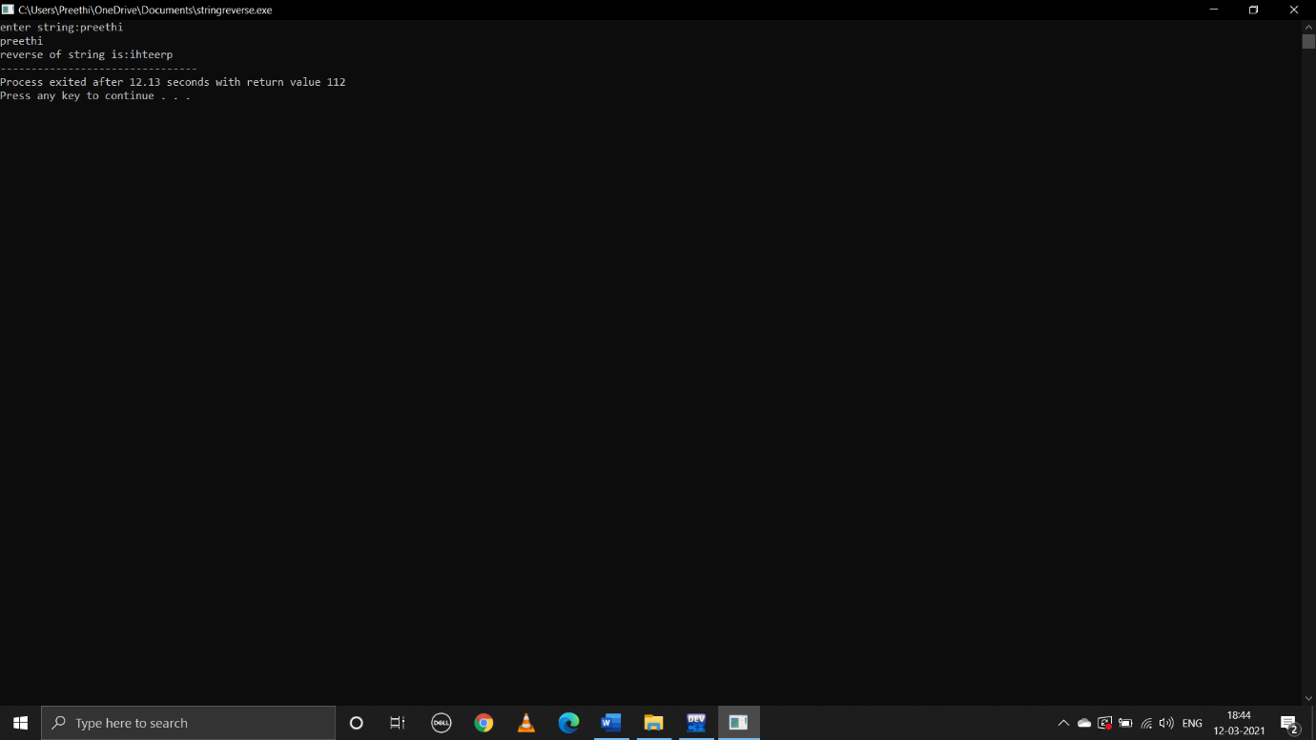

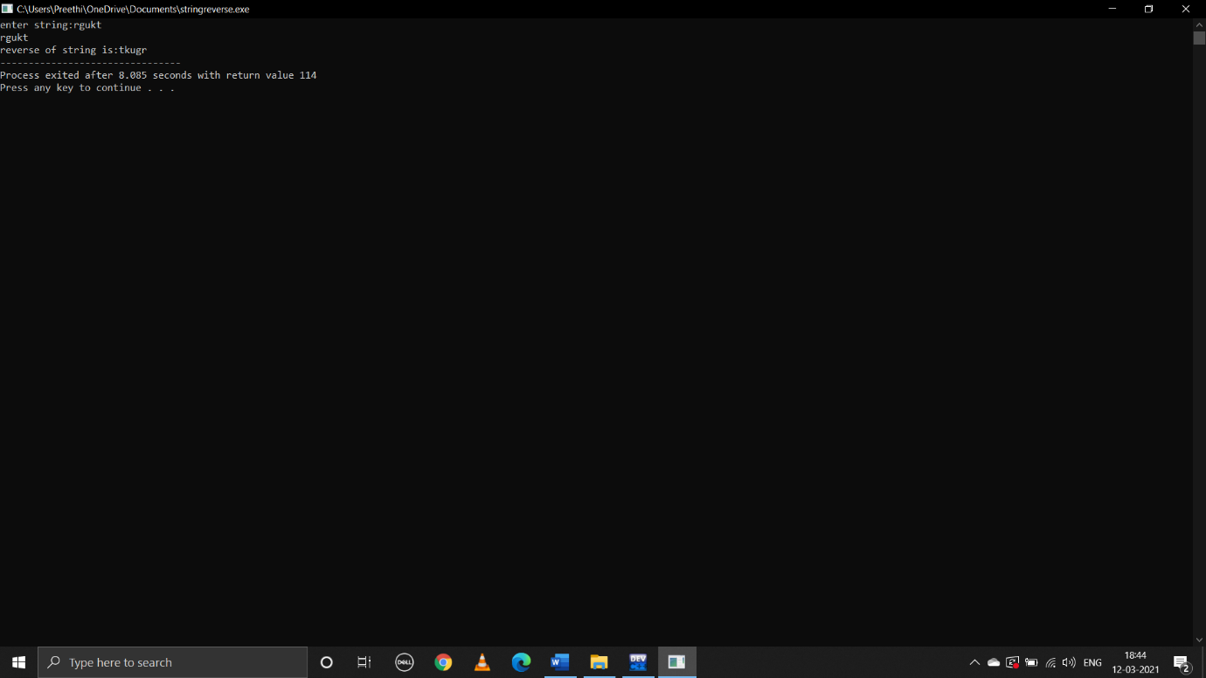

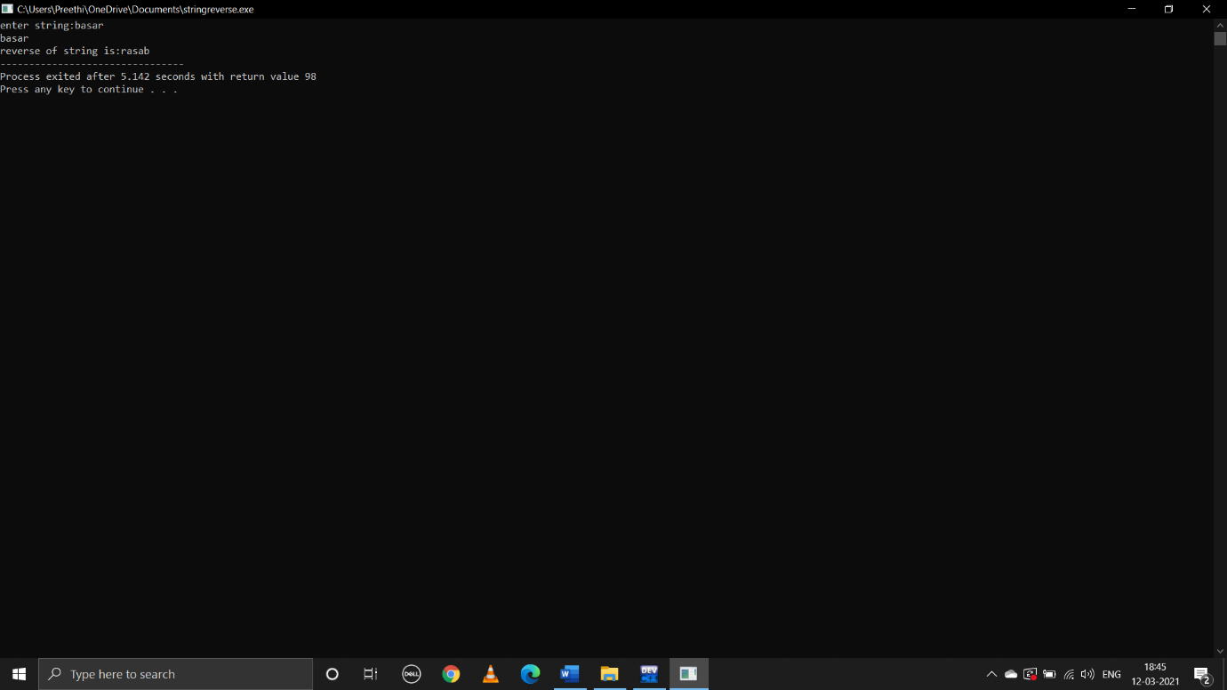

**5.write a c program strLwr()**

**Pseudocode:**

Begin

Take input string

Run loop from i=0 to end character ‘\0’

Change every character of string to lowercase if it is in uppercase

If(a[i]>=’A’&&a[i]<=’Z’)

Print(“%c”,a[i]+32)

end

**C program:**

#include<stdio.h>

#include<string.h>

void main()

{

char a[100];

printf("enter a string:");

gets(a);

puts(a);

int i;

for(i=0;a[i]!='\0';i++)

{

if(a[i]>='A'&&a[i]<='Z')

{

printf("%c",a[i]+32);

}

}

}

**Output:**

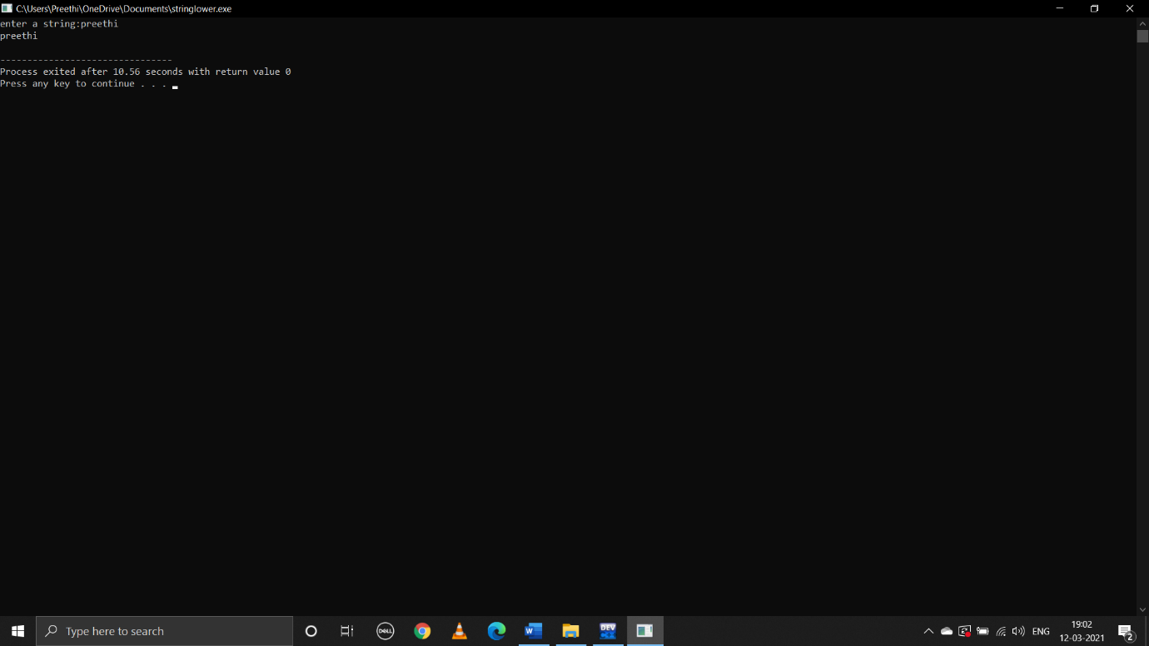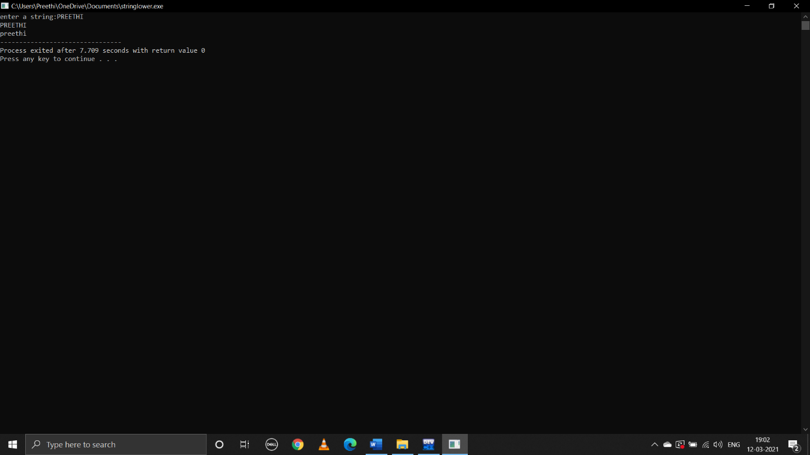

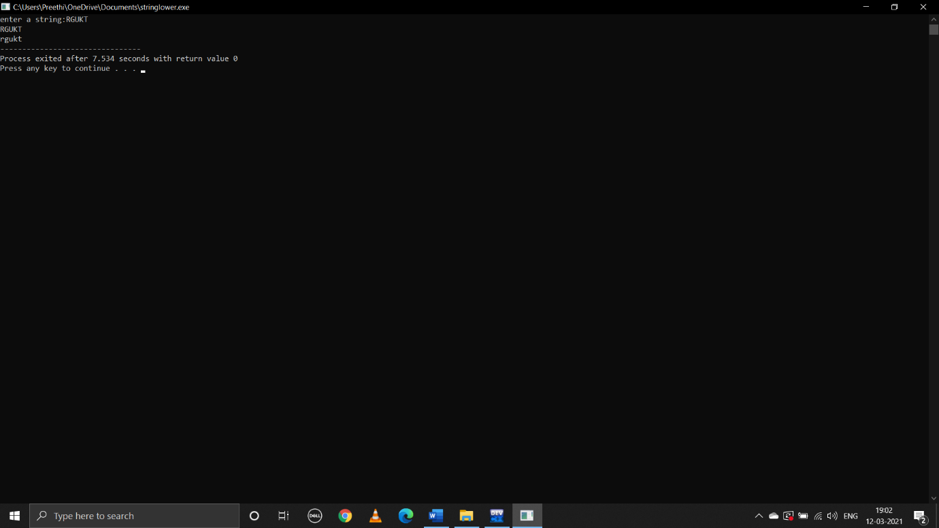

**6.write a c program to strUpr()**

**Pseudocode:**

Begin

Take input string a

Run loop from i=0 to end character ‘\0’

Change every character to uppercase if it is lowercase

If(a[i]>=’a’&&a[i]<=’z’)

Print(“%c”,a[i]-32)

end

**C program:**

#include<stdio.h>

#include<string.h>

void main()

{

char a[100];

int i;

printf("enter a string:");

gets(a);

puts(a);

for(i=0;a[i]!='\0';i++)

{

if(a[i]>='a'&&a[i]<='z')

{

printf("%c",a[i]-32);

}

}

}

**Output:**

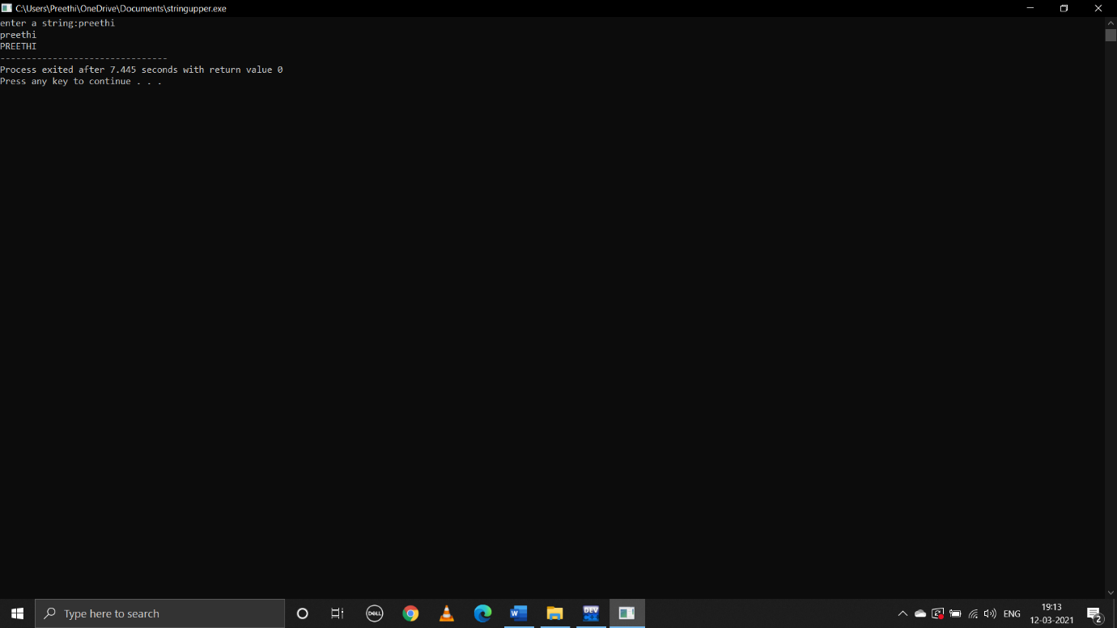

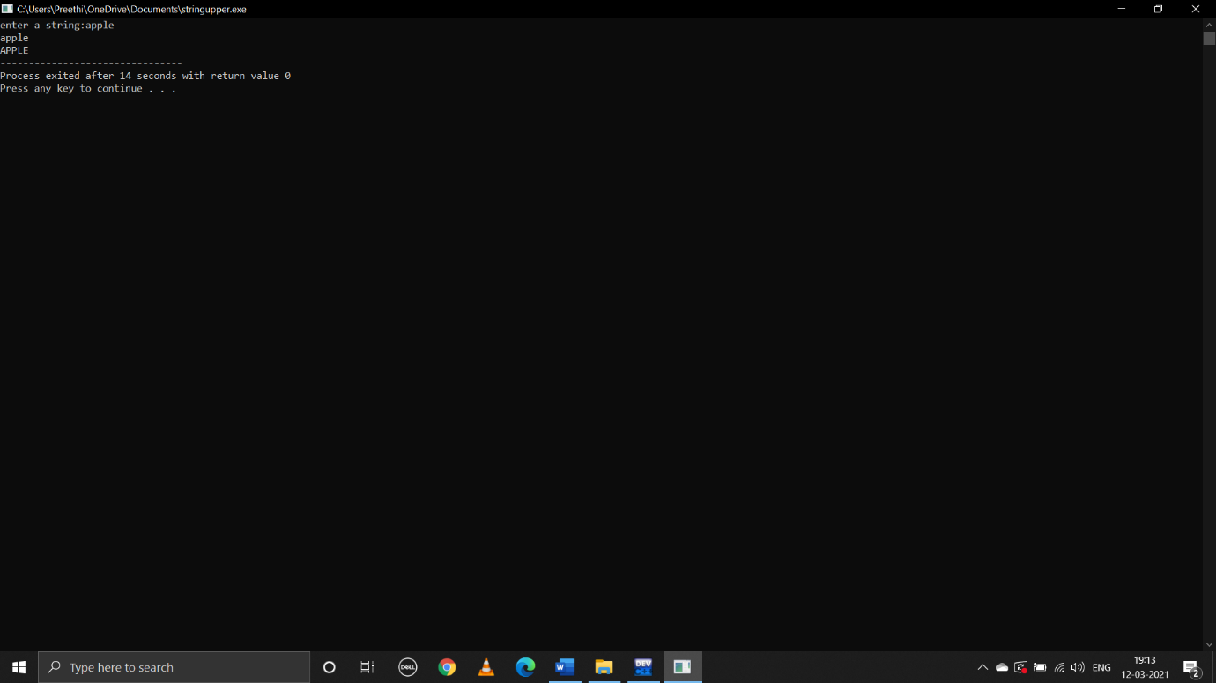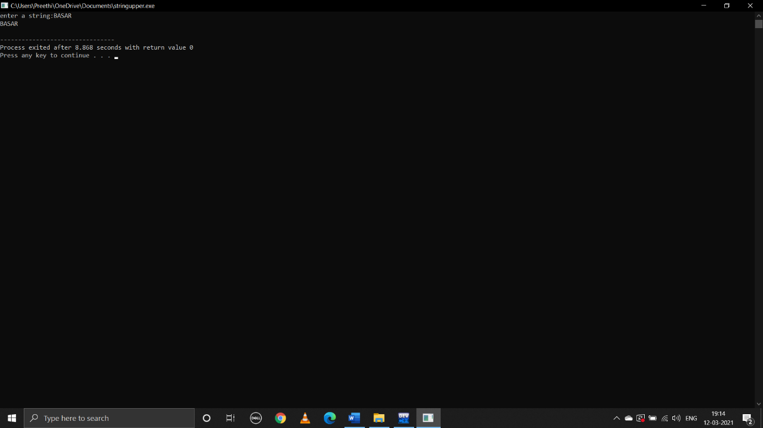

**7.write c program for strLen()**

**Pseudocode:**

Begin

Take input string 1

Declare len=0

Run loop from 0 to end character ‘\0’

Add 1 to len for every iteration

Len=len+1

Print len

end

**C program:**

#include<stdio.h>

#include<string.h>

void main()

{

char string1[1000];

printf("enter string:");

gets(string1);

puts(string1);

int i,len=0;

for(i=0;string1[i]!='\0';i++)

{

len=len+1;

}

printf("length of %s is %d",string1,len);

}

**Output:**

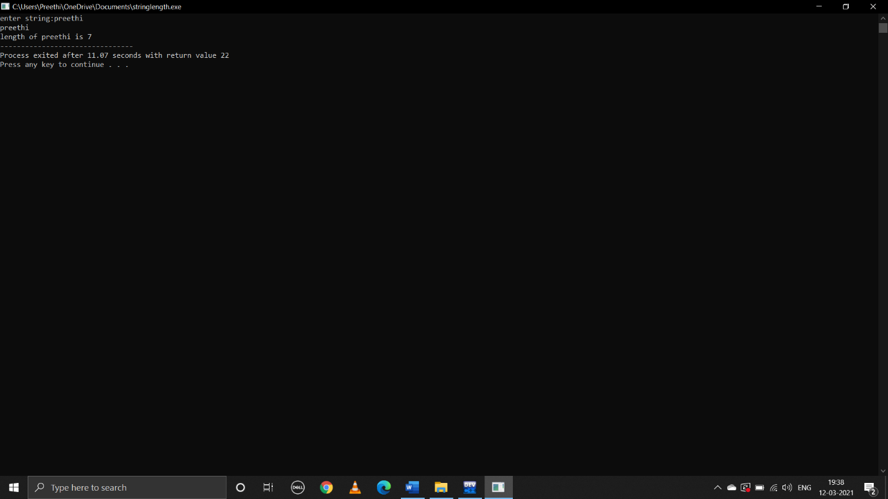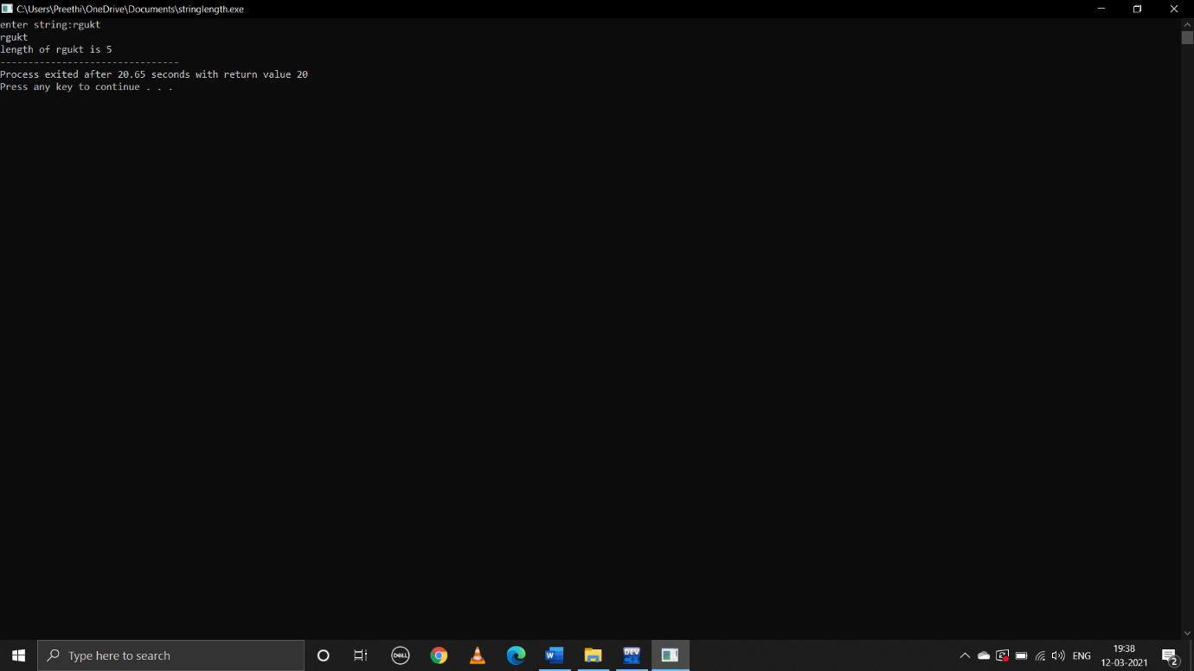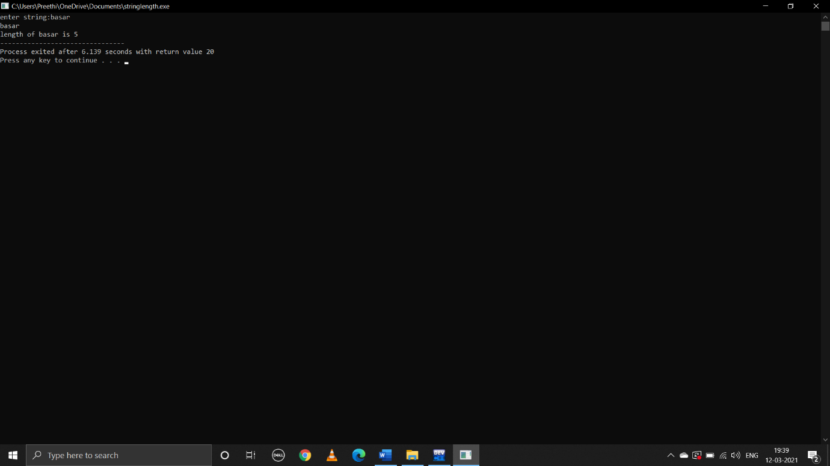

**8.write c program to print subStr(m,n)**

**Pseudocode:**

Begin

Take input string

Declare substr[]

Declare int m,n

m is starting index of input string

n is length of substring

declare i=0

use while loop

while(i<n)

substr[i]=str(=[m+i-1]

print(substr)

end

**C program:**

void main()

{

char str[1000],substr[1000];

printf("enter string:");

gets(str);

puts(str);

int m,n;

printf("enter starting index:");

scanf("%d",&m);

printf("enter no.of characters:");

scanf("%d",&n);

int i=0;

while(i<n)

{

substr[i]=str[m+i-1];

i++;

}

printf("substring is:%s",substr);

}

**Output:**

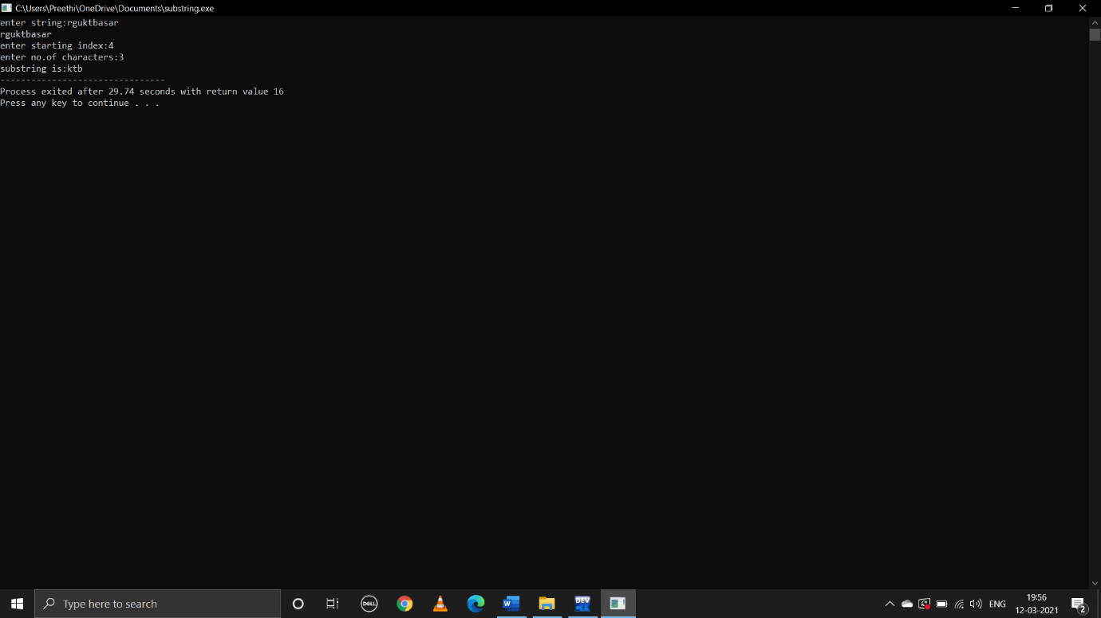

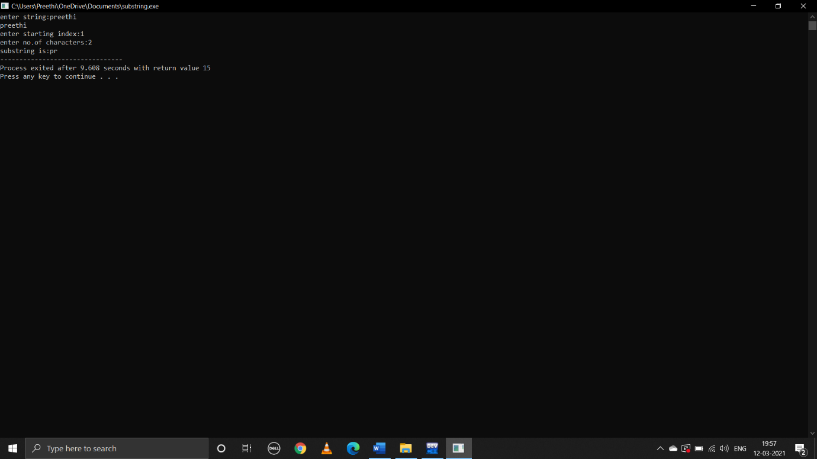

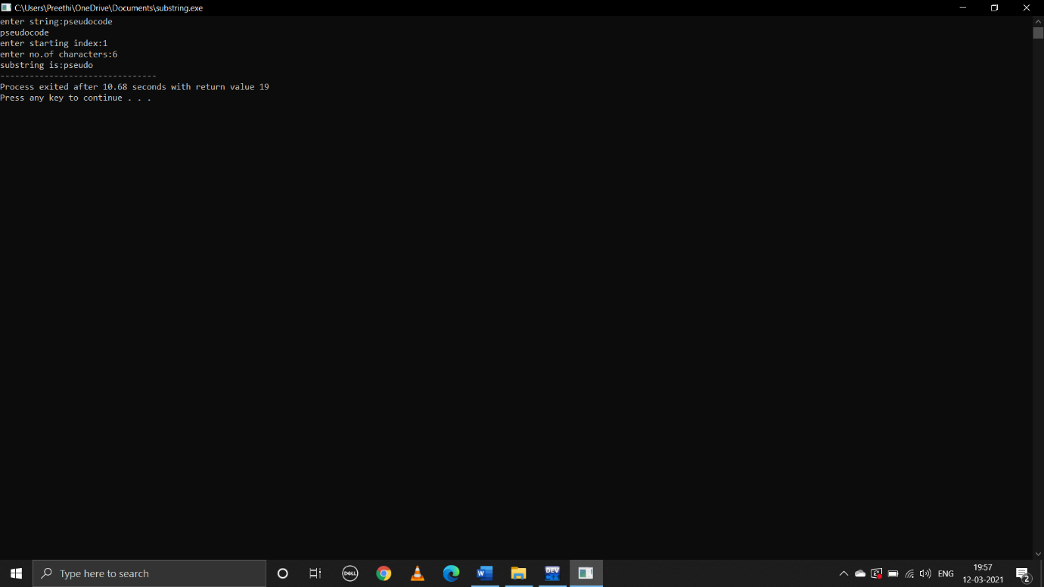

**DONE BY**

B.preethi

ID:B181356

Class:AB-2 ,305 CSE-1